1.Calaveras Tire exchanged equipment for two pickup trucks. The book value and fair value of the equipment given up were $25,000 (original cost of $72,500 less accumulated depreciation of $47,500) and $19,500, respectively. Assume Calaveras paid $5,500 in cash and the exchange has commercial substance.  
  
(1) At what amount will Calaveras value the pickup trucks?  
(2) How much gain or loss will the company recognize on the exchange?

(1)Value of pickup trucks$25,000

(2)Loss on exchange$5,500

**Explanation**

**1.**  
Pickup trucks = Fair value of equipment given, plus cash paid  
$19,500 + $5,500 = $25,000  
  
**2.**  
Gain or loss to recognize on the exchange:

|  |  |  |  |  |  |  |  |  |
| --- | --- | --- | --- | --- | --- | --- | --- | --- |
|  |  |  |  |  |  |  |  |  |
| Fair value of equipment given up |  |  |  |  | $ | 19,500 |  |  |
| Less: Book value of equipment |  |  |  |  |  |  |  |  |
| Original cost of equipment | $ | 72,500 |  |  |  |  |  |  |
| Accumulated depreciation |  | (47,500 | ) |  |  | (25,000 | ) |  |
| Loss on exchange of assets |  |  |  |  | $ | (5,500 | ) |  |
|  | | | | | | | | |

2. A company constructs a building for its own use. Construction began on January 1 and ended on December 30. The expenditures for construction were as follows: January 1, $650,000; March 31, $750,000; June 30, $550,000; October 30, $1,050,000. To help finance construction, the company arranged a 10% construction loan on January 1 for $1,000,000. The company’s other borrowings, outstanding for the whole year, consisted of a $4 million loan and a $6 million note with interest rates of 13% and 11%, respectively.  
   
Assuming the company uses the *specific interest method,* calculate the amount of interest capitalized for the year. **(Do not round intermediate calculations. Round your percentage answers to 2 decimal places (i.e. 0.1234 should be entered as 12.34%).)**

DateExpenditureWeightAverage

January 1$650,000×12/12=$650,000

March 31750,000×9/12=562,500

June 30550,000×6/12=275,000

October 301,050,000×2/12=175,000

Accumulated expenditures$3,000,000

$1,662,500

Average Interest RateCapitalized InterestAverage

accumulated expenditures$1,662,500

Construction loan1,000,00010.00%=$100,000

Other loans (not construction)662,50011.80%=78,175

$178,175  
  

**Explanation**

Weighted-average rate of all other debt:

|  |  |  |  |  |  |  |  |  |  |
| --- | --- | --- | --- | --- | --- | --- | --- | --- | --- |
|  |  | | | | | | | |  |
|  | $ | 4,000,000 | × | 13 | % | = | $ | 520,000 |  |
|  |  | 6,000,000 | × | 11 | % | = |  | 660,000 |  |
|  | $ | 10,000,000 |  |  |  |  | $ | 1,180,000 |  |
|  | | | | | | | | | |

|  |  |  |  |  |
| --- | --- | --- | --- | --- |
| $1,180,000 | = | 11.80 | % | weighted average |
| $10,000,000 |

3.

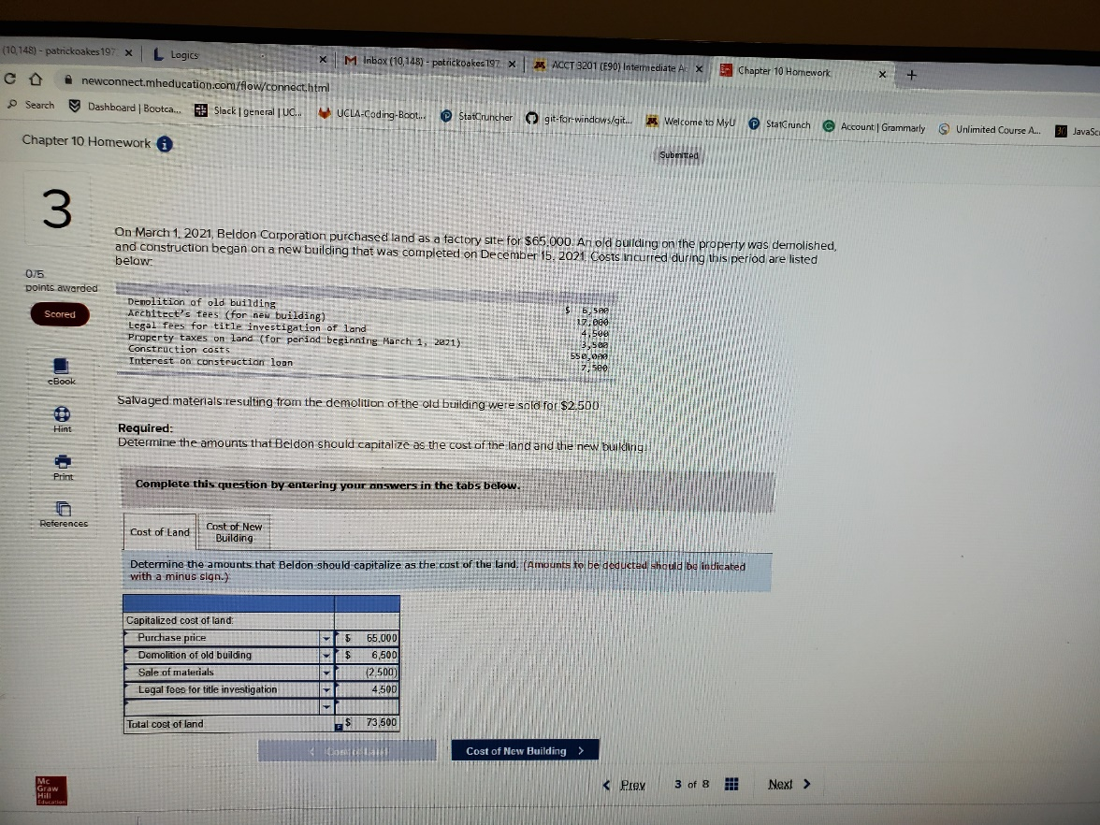

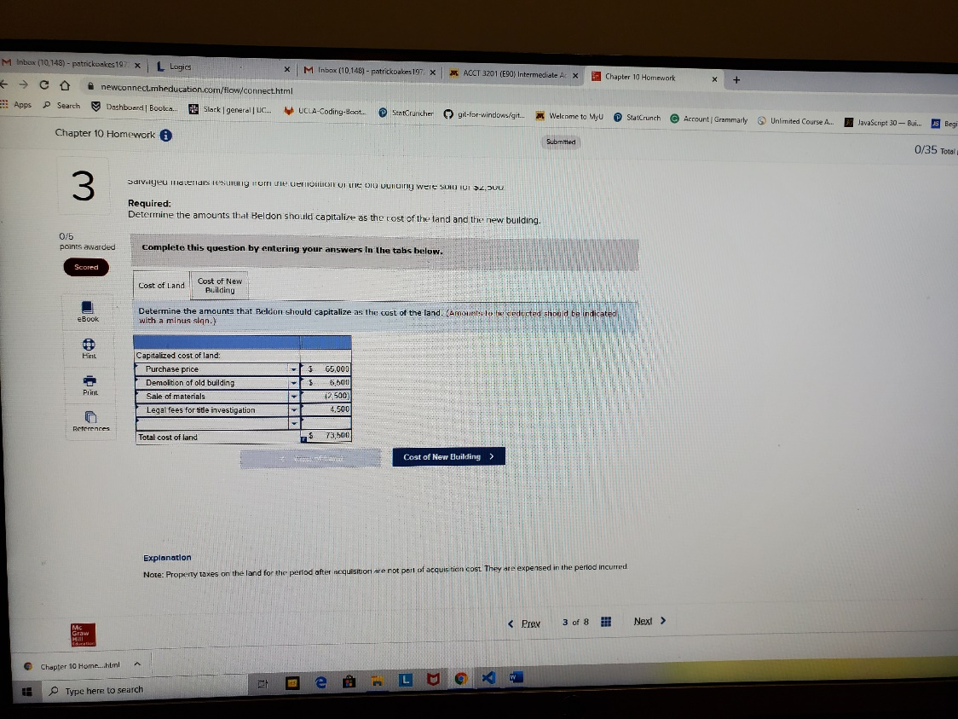

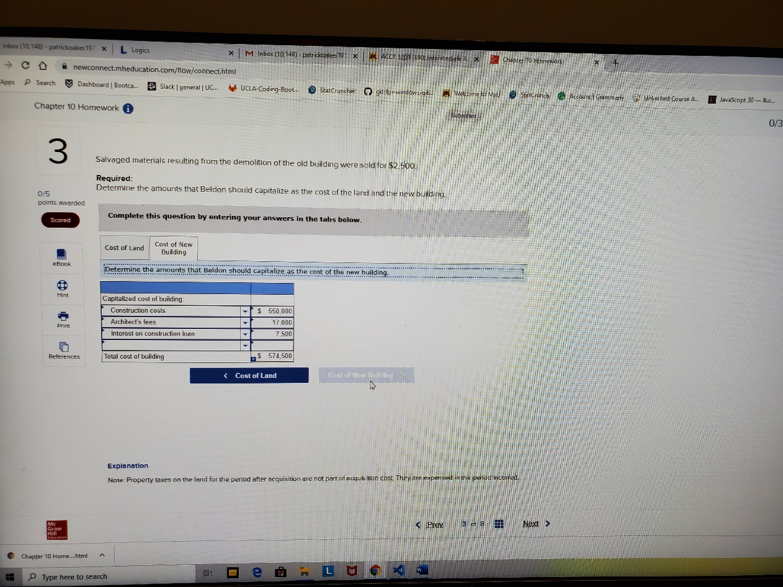

## Explanation

Note: Property taxes on the land for the period after acquisition are not part of acquisition cost. They are expensed in the period incurred.

4. Samtech Manufacturing purchased land and building for $5 million. In addition to the purchase price, Samtech made the following expenditures in connection with the purchase of the land and building:

|  |  |  |  |
| --- | --- | --- | --- |
|  | | | |
| Title insurance | $ | 28,000 |  |
| Legal fees for drawing the contract |  | 6,000 |  |
| Pro-rated property taxes for the period after acquisition |  | 48,000 |  |
| State transfer fees |  | 5,200 |  |
|  | | | |

An independent appraisal estimated the fair values of the land and building, if purchased separately, at $3.6 and $2.4 million, respectively. Shortly after acquisition, Samtech spent $94,000 to construct a parking lot and $52,000 for landscaping.  
   
**Required:**  
**1.** Determine the initial valuation of each asset Samtech acquired in these transactions.  
**2.** Determine the initial valuation of each asset, assuming that immediately after acquisition, Samtech demolished the building. Demolition costs were $370,000 and the salvaged materials were sold for $7,000. In addition, Samtech spent $91,000 clearing and grading the land in preparation for the construction of a new building.

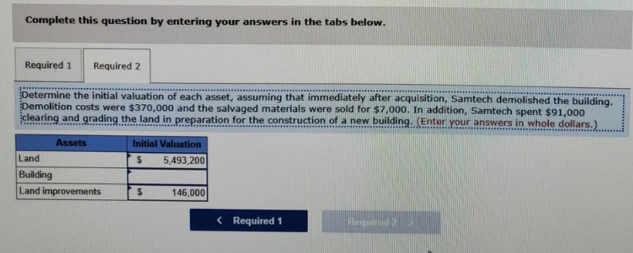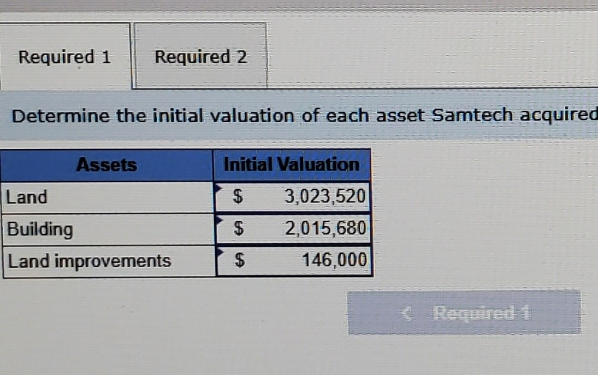

**Explanation**

**1.**

|  |  |  |  |
| --- | --- | --- | --- |
|  | | | |
| Cost of land and building: |  | | |
| Purchase price | $ | 5,000,000 |  |
| Title insurance |  | 28,000 |  |
| Legal fees |  | 6,000 |  |
| State transfer fees |  | 5,200 |  |
| Total cost | $ | 5,039,200 |  |
|  | | | |

Note: The pro-rated property taxes for the period after acquisition are not included in the initial valuation of the land and building. They are recorded instead as prepaid taxes and expensed over the related period.

The total is allocated to the land and building based on their relative fair values:

|  |  |  |  |  |  |  |  |  |  |  |  |  |
| --- | --- | --- | --- | --- | --- | --- | --- | --- | --- | --- | --- | --- |
| Asset | Fair Value | | | | Percent of Total Fair Value | | | | Initial Valuation (% × $5,039,200) | | | |
| Land |  | $ | 3,600,000 |  |  | 60 | % |  |  | $ | 3,023,520 |  |
| Building |  |  | 2,400,000 |  |  | 40 | % |  |  |  | 2,015,680 |  |
|  |  | $ | 6,000,000 |  |  | 100 | % |  |  | $ | 5,039,200 |  |
|  | | | | | | | | | | | | |

|  |  |  |
| --- | --- | --- |
|  | | |
| Assets: |  |  |
| Land | $ | 3,023,520 |
| Building | $ | 2,015,680 |
| Land improvements: |  |  |
| Parking lot | $ | 94,000 |
| Landscaping |  | 52,000 |
|  | $ | 146,000 |
|  | | |

**2.**

|  |  |  |  |  |  |  |  |
| --- | --- | --- | --- | --- | --- | --- | --- |
|  | | | | | | | |
| Cost of land: |  |  |  |  |  |  |  |
| Purchase price |  |  |  |  | $ | 5,000,000 |  |
| Title insurance |  |  |  |  |  | 28,000 |  |
| Legal fees |  |  |  |  |  | 6,000 |  |
| State transfer fees |  |  |  |  |  | 5,200 |  |
| Demolition of old building | $ | 370,000 |  |  |  |  |  |
| Less: Sale of materials |  | (7,000 | ) |  |  | 363,000 |  |
| Clearing and grading costs |  |  |  |  |  | 91,000 |  |
| Total cost of land |  |  |  |  | $ | 5,493,200 |  |
| Land improvements: |  |  |  |  |  |  |  |
| Parking lot |  |  |  |  |  | 94,000 |  |
| Landscaping |  |  |  |  | $ | 52,000 |  |
|  |  |  |  |  | $ | 146,000 |  |
|  | | | | | | | |

5. On January 1, 2021, the Highlands Company began construction on a new manufacturing facility for its own use. The building was completed in 2022. The company borrowed $1,750,000 at 8% on January 1 to help finance the construction. In addition to the construction loan, Highlands had the following debt outstanding throughout 2021:

|  |  |
| --- | --- |
|  | |
| $8,000,000, 13% bonds |  |
| $2,000,000, 8% long-term note |  |
|  | |

Construction expenditures incurred during 2021 were as follows:

|  |  |  |  |
| --- | --- | --- | --- |
|  | | | |
| January 1 | $ | 760,000 |  |
| March 31 |  | 1,360,000 |  |
| June 30 |  | 992,000 |  |
| September 30 |  | 760,000 |  |
| December 31 |  | 560,000 |  |
|  | | | |

**Required:**  
Calculate the amount of interest capitalized for 2021 using the specific interest method. **(Do not round the intermediate calculations. Round your percentage answers to 1 decimal place (i.e. 0.123 should be entered as 12.3%).)**

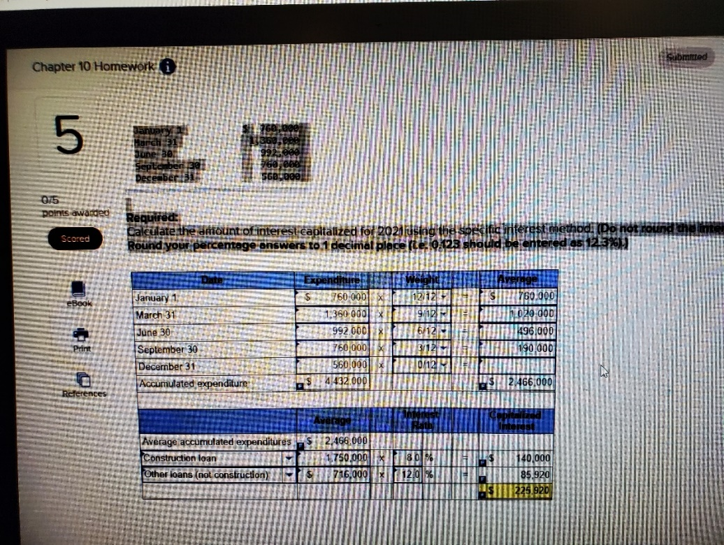

**Explanation**

Weighted-average rate of all other debt:

|  |  |  |  |  |  |  |  |  |  |  |
| --- | --- | --- | --- | --- | --- | --- | --- | --- | --- | --- |
|  |  | | | | | | | | | |
|  | $ | 8,000,000 | × | 13 | % | = | $ | 1,040,000 |  |  |
|  |  | 2,000,000 | × | 8 | % | = |  | 160,000 |  |  |
|  | $ | 10,000,000 |  |  |  |  | $ | 1,200,000 |  |  |
|  | | | | | | | | | |  |

|  |  |
| --- | --- |
| $1,200,000 | = 12.00% |
| $10,000,000 |

6. Tristar Production Company began operations on September 1, 2021. Listed below are a number of transactions that occurred during its first four months of operations. ([FV of $1](https://ezto.mheducation.com/extMedia/bne/accounting/spiceland_int_9e/images/fv_of_1.jpg), [PV of $1](https://ezto.mheducation.com/extMedia/bne/accounting/spiceland_int_9e/images/pv_of_1.jpg), [FVA of $1](https://ezto.mheducation.com/extMedia/bne/accounting/spiceland_int_9e/images/fva_of_1.jpg), [PVA of $1](https://ezto.mheducation.com/extMedia/bne/accounting/spiceland_int_9e/images/pva_of_1.jpg), [FVAD of $1](https://ezto.mheducation.com/extMedia/bne/accounting/spiceland_int_9e/images/fvad_of_1.jpg) and [PVAD of $1](https://ezto.mheducation.com/extMedia/bne/accounting/spiceland_int_9e/images/pvad_of_1.jpg)) **(Use appropriate factor(s) from the tables provided.)**

1. On September 1, the company acquired five acres of land with a building that will be used as a warehouse. Tristar paid $270,000 in cash for the property. According to appraisals, the land had a fair value of $185,600 and the building had a fair value of $104,400.
2. On September 1, Tristar signed a $57,000 noninterest-bearing note to purchase equipment. The $57,000 payment is due on September 1, 2022. Assume that 9% is a reasonable interest rate.
3. On September 15, a truck was donated to the corporation. Similar trucks were selling for $4,200.
4. On September 18, the company paid its lawyer $6,000 for organizing the corporation.
5. On October 10, Tristar purchased maintenance equipment for cash. The purchase price was $32,000 and $1,350 in freight charges also were paid.
6. On December 2, Tristar acquired various items of office equipment. The company was short of cash and could not pay the $7,200 normal cash price. The supplier agreed to accept 200 shares of the company's no-par common stock in exchange for the equipment. The fair value of the stock is not readily determinable.
7. On December 10, the company acquired a tract of land at a cost of $37,000. It paid $6,000 down and signed a 11% note with both principal and interest due in one year. Eleven percent is an appropriate rate of interest for this note.

**Required:**

Prepare journal entries to record each of the above transactions. **(If no entry is required for a transaction/event, select "No journal entry required" in the first account field. Round final answers to the nearest whole dollars.)**

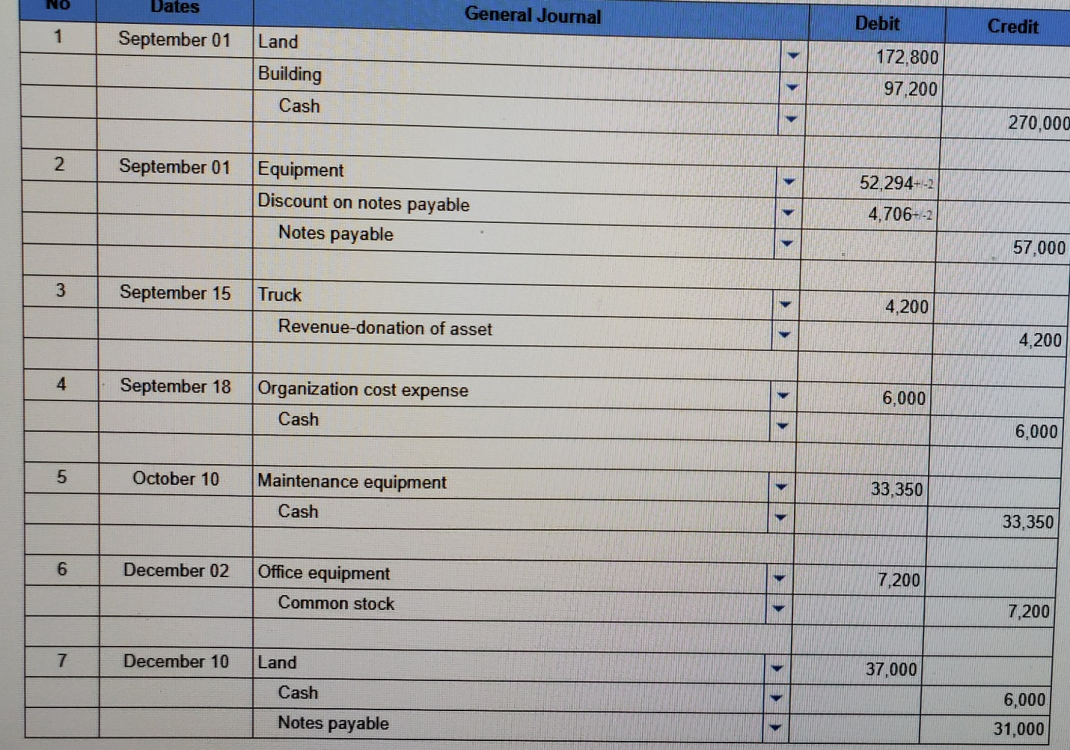

## Explanation

**1.**

|  |  |  |  |  |  |  |  |  |  |  |  |  |
| --- | --- | --- | --- | --- | --- | --- | --- | --- | --- | --- | --- | --- |
| Asset | Fair Value | | | | Percent of Total Fair Value | | | | Initial Valuation (Percent × $270,000) | | | |
| Land |  | $ | 185,600 |  |  | 64.00 | % |  |  | $ | 172,800 |  |
| Building |  |  | 104,400 |  |  | 36.00 |  |  |  |  | 97,200 |  |
| Totals |  | $ | 290,000 |  |  | 100.00 | % |  |  | $ | 270,000 |  |
|  | | | | | | | | | | | | |

**2.**  
Present value of note payments:  
   
PV = $57,000 (0.91743*) = $52,294  
*Present value of $1: *n* = 1, *i* = 9% (from PV of $1)  
    
**5.**  
Equipment = $32,000 + $1,350 = $33,350

7. Consider each of the transactions below. All of the expenditures were made in cash.

1. The Edison Company spent $18,000 during the year for experimental purposes in connection with the development of a new product.
2. In April, the Marshall Company lost a patent infringement suit and paid the plaintiff $5,000.
3. In March, the Cleanway Laundromat bought equipment. Cleanway paid $12,000 down and signed a noninterest-bearing note requiring the payment of $21,000 in nine months. The cash price for this equipment was $29,000.
4. On June 1, the Jamsen Corporation installed a sprinkler system throughout the building at a cost of $34,000.
5. The Mayer Company, plaintiff, paid $18,000 in legal fees in November, in connection with a successful infringement suit on its patent.
6. The Johnson Company traded its old equipment for new equipment. The new equipment has a fair value of $11,800. The old equipment had an original cost of $10,400 and a book value of $4,800 at the time of the trade. Johnson also paid cash of $9,200 as part of the trade. The exchange has commercial substance.

**Required:**

Prepare journal entries to record each of the above transactions.

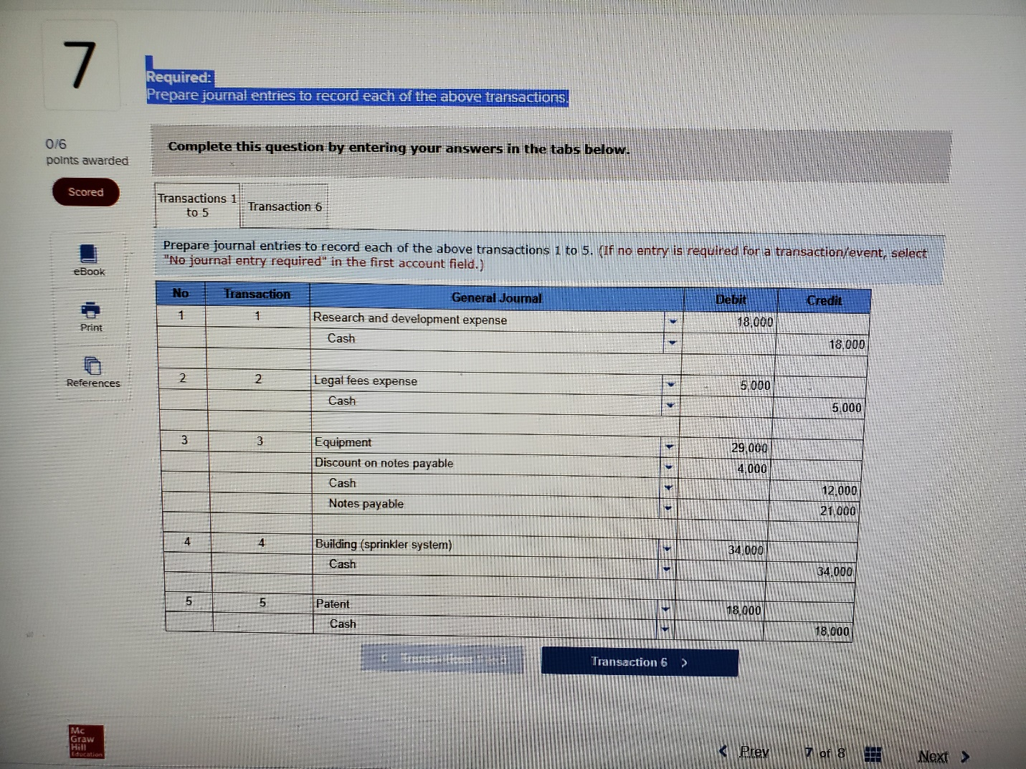

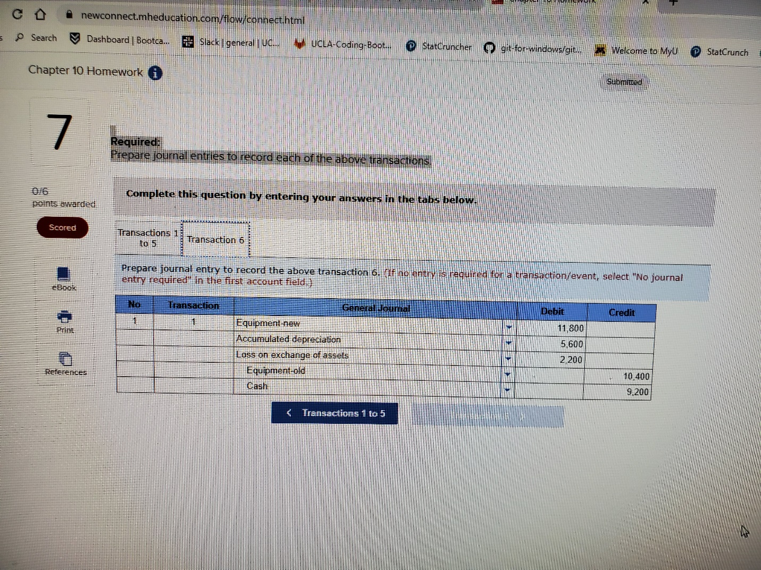

## Explanation

**6.**  
Equipment-new ($2,600 FV given* + $9,200 cash paid) = $11,800  
Accumulated depreciation-machine ($10,400 cost – $4,800 BV) = $5,600  
Loss on exchange of assets ($2,600 FV* – $4,800 BV) = $2,200  
Equipment—old (remove account balance) = $10,400  
  
*Fair value of old equipment (Fair value of new equipment – Cash given):  
$11,800 – $9,200 = $2,600

8. On September 3, 2021, the Robers Company exchanged equipment with Phifer Corporation. The facts of the exchange are as follows:

|  |  |  |  |  |  |  |
| --- | --- | --- | --- | --- | --- | --- |
|  | Robers’ Asset | | | Phifer’s Asset | | |
| Original cost | $ | 220,000 |  | $ | 240,000 |  |
| Accumulated depreciation |  | 135,000 |  |  | 143,000 |  |
| Fair value |  | 105,000 |  |  | 80,000 |  |
|  | | | | | | |

To equalize the exchange, Phifer paid Robers $25,000 in cash.  
  
**Required:**  
Record the exchange for both Robers and Phifer. The exchange has commercial substance for both companies. **(If no entry is required for a transaction/event, select "No journal entry required" in the first account field.)**

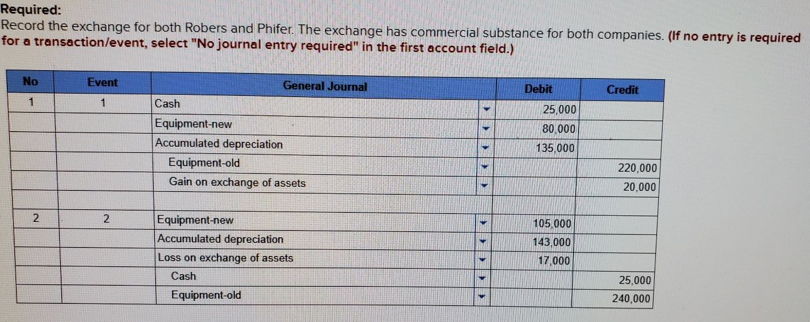

## Explanation

Robers Company:  
Equipment―new ($105,000 FV given − $25,000 cash received) = $80,000  
Gain on exchange of assets ($105,000 FV − $85,000 BV) = $20,000  
  
Phifer Company:  
Equipment―new ($80,000 FV given + $25,000 cash paid) = $105,000  
Loss on exchange of assets ($80,000 FV − $97,000 BV) = $17,000